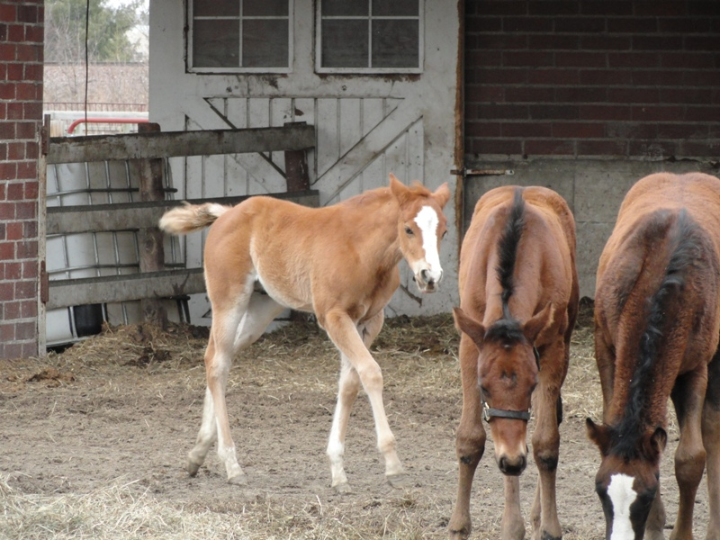

Image 1

Title: Foal Demonstration Case - without solution

Directions for using this Applied Learning Activity at WhenKnowingMatters.com:

1) Select everything in this document. (Windows Ctrl+A or Mac Option+A)

2) Copy the selected text to your clipboard. (Windows Ctrl+C or Mac Option+C)

3) Navigate to <http://WhenKnowingMatters.com>.

4) Start the Applied Learning Platform by hovering your cursor over the menu option, Applied Learning Platform and selecting "Start ALP Basic".

5) Choose "Begin an activity."

6) Follow the instructions for pasting the content of your clipboard into the box.

\*\*\*\*\*\*\*\*\*\*\*\*\*\*\*\*\*\*\*\*\*\*\*\*\*\*\*\*\*\*\*\*\*\*\*\*\*\*\*\*\*\*\*\*\*\*\*\*\*\*\*\*\*\*\*\*\*\*\*\*\*\*\*\*\*\*\*\*\*

The computer generated XML markup tags for this Applied Learning Activity can be viewed by scrolling down through this document.

Foal Demonstration Case - without solution Markup

Tue Jan 19 09:40:19 GMT-0600 2016

<Title>Foal Demonstration Case - without solution</Title>

<Presenting Information Abbreviation>O Observation</Presenting Information Abbreviation>

<Formulation Abbreviation>A Assertion</Formulation Abbreviation>

<Framework Abbreviation>F Framework</Framework Abbreviation>

<Additional Abbreviations>H History, M Mechanism, D Diagnosis</Additional Abbreviations>

<Formulation Relationships>supported by, indicates, causes, occurs with, results in, results from</Formulation Relationships>

<Upper Formulation Term>Assessment</Upper Formulation Term>

<Lower Formulation Term>assessment</Lower Formulation Term>

<Upper Relevant Observation Term>Relevant Observations</Upper Relevant Observation Term>

<Lower Relevant Observation Term>relevant observations</Lower Relevant Observation Term>

<Presenting Information>

<TEXTFORMAT LEFTMARGIN="10" LEADING="2"><P ALIGN="CENTER"><FONT FACE="Arial" SIZE="14" COLOR="#000000" LETTERSPACING="0" KERNING="0">(refer to the image attached to the email that you received containing this case) </FONT></P></TEXTFORMAT><TEXTFORMAT LEFTMARGIN="10" LEADING="2"><P ALIGN="CENTER"><FONT FACE="Arial" SIZE="14" COLOR="#000000" LETTERSPACING="0" KERNING="0"></FONT></P></TEXTFORMAT><TEXTFORMAT LEFTMARGIN="10" LEADING="2"><P ALIGN="CENTER"><FONT FACE="Arial" SIZE="14" COLOR="#000000" LETTERSPACING="0" KERNING="0"><B>History</B></FONT></P></TEXTFORMAT><TEXTFORMAT LEFTMARGIN="10" LEADING="2"><P ALIGN="LEFT"><FONT FACE="Arial" SIZE="14" COLOR="#000000" LETTERSPACING="0" KERNING="0">You are a practitioner with an interest in equine medicine. During a routine visit to an area stable, your client asks you to perform a physical examination and to draw blood and collect urine from a near weaning Thoroughbred foal for future sale. The potential buyer wants a routine examination before purchasing the animal. </FONT></P></TEXTFORMAT><TEXTFORMAT LEFTMARGIN="10" LEADING="2"><P ALIGN="CENTER"><FONT FACE="Arial" SIZE="14" COLOR="#000000" LETTERSPACING="0" KERNING="0"></FONT></P></TEXTFORMAT><TEXTFORMAT LEFTMARGIN="10" LEADING="2"><P ALIGN="CENTER"><FONT FACE="Arial" SIZE="14" COLOR="#000000" LETTERSPACING="0" KERNING="0"><B>Physical examination</B></FONT></P></TEXTFORMAT><TEXTFORMAT LEFTMARGIN="10" LEADING="2"><P ALIGN="LEFT"><FONT FACE="Arial" SIZE="14" COLOR="#000000" LETTERSPACING="0" KERNING="0">The foal is high spirited and makes the client chase him around the paddock a few times before he can be haltered. Eventually, no abnormalities were found on physical examination.</FONT></P></TEXTFORMAT><TEXTFORMAT LEFTMARGIN="10" LEADING="2"><P ALIGN="LEFT"><FONT FACE="Arial" SIZE="14" COLOR="#000000" LETTERSPACING="0" KERNING="0"></FONT></P></TEXTFORMAT><TEXTFORMAT LEFTMARGIN="10" LEADING="2"><P ALIGN="LEFT"><FONT FACE="Arial" SIZE="14" COLOR="#000000" LETTERSPACING="0" KERNING="0">What do you see in Image 1 that could be of concern?</FONT></P></TEXTFORMAT>

</Presenting Information>

<Contributors><TEXTFORMAT LEADING="2"><P ALIGN="LEFT"><FONT FACE="Arial" SIZE="14" COLOR="#000000" LETTERSPACING="0" KERNING="1">This case is used with permission from Dr. Holly Bender.</FONT></P></TEXTFORMAT></Contributors>

<Tables>



</Tables>

<Framework>



</Framework>

<Case Elements>

biwPDj8MDR9sVSUZMwQGHD0bCEsTHwICPggBBzdGXVd9LA8OPwwNH2xjXy4+DA4OPB1dVwAMBQ4gDA0IN0klBCAEFgczHQoEPEkiHTMADwowBQZEbFVMLj4MDg48HV1h

</Case Elements>